P250/1

**GEOGRAPHY**

(Physical Geography)

**Jul. Aug. 2023**

PAPER 1

**3 hours**



**Uganda Advanced Certificate of Education**

GEOGRAPHY

**(PHYSICAL GEOGRAPHY)**

Paper 1

**3 hours**

# INSTRUCTIONS TO CANDIDATES:

*This paper consists of* ***three*** *sections* ***A, B*** *and* ***C.*** *Answer only* ***four*** *questions.*

*Section* ***A i****s compulsory.*

*Answer* ***one*** *question from Section* ***B*** *and* ***one*** *question from Section* ***C.***

*Any additional question(s) answered will not be marked.*

*Credit will be given for the use of relevant sketch-maps, diagrams and specific examples studied in the field.*

# SECTION A

*Questions* **1** *and* **2** *are* **compulsory**

**COMPULSORY MAPWORK QUESTION:**

1. Study the East Africa 1:50,000 (UGANDA), **BUDADIRI** Map extract; part of sheet 54/4 (Kenya Sheet, 74W/4, Series Y732; Edition 2-U.S.D. and answer the following questions.
   1. (i) State the grid reference of the bridge across Sanoli River. (01 mark)

(ii) Name the feature found at grid reference 476252. (01 mark)

* 1. (i) Measure and state the bearing of Bukalasi Trigonometrical station (grid

reference 569132) from the bridge at Bukiga (grid reference 494164).

(01 mark)

(ii) Calculate the ground area in kilometres squared of Buyobo sub-county

shown on the map extract. (02 marks)

* 1. (i) Draw a cross section of the area along Northing 30 between Eastings 42

and 50 and on it mark and label the following:

* Gently sloping areas
* Buyola hill
* Broad River valley
* All-weather road
* Sanoli River
* Nakiwondwe forest reserve (10 marks)

(ii) Explain why it is important to exaggerate the height scale of a cross

sectional drawing. (02 marks)

* 1. With evidence from the map extract, identify the economic activities carried out in the area. (04 marks)
  2. Explain how relief has influenced the nature of drainage in the area shown on the map extract. (04 marks)

# COMPULSORY QUESTION:

# PHOTOGRAPHIC INTERPRETATION

1. Study the photograph provided below and answer the questions that follow:

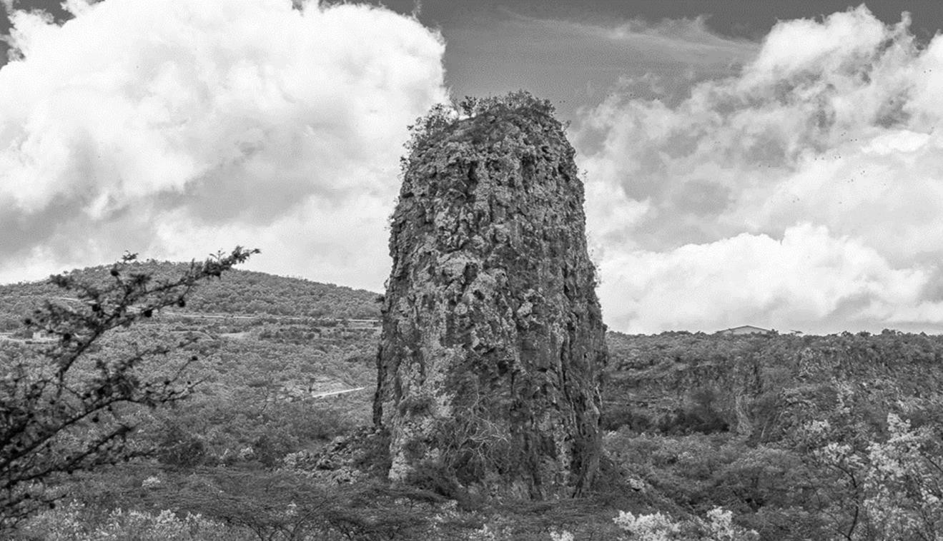

* 1. Draw a landscape sketch of the area shown on the photograph and on it mark and label the:
* Landform features
* Main vegetation type
* **Two** types of human features
* Type of clouds above the horizon (09 marks)
  1. Account for the formation of the prominent landform feature in the middle foreground of the photograph. (04 marks)
  2. (i) Explain how the clouds shown in the photograph were formed.

(04 marks)

(ii) Examine the significance of the cloud cover to the weather and climatic

conditions of the area shown in the photograph. (06 marks)

* 1. Giving reasons for your answer, suggest an area in East Africa where this photograph could have been taken. (02 marks)

# SECTION B:

*Answer* ***one*** *question from this section*

1. (a) Identify the sources of heat in the earth’s interior that may trigger off

tectonic processes. (08 marks)

(b) Relate the nature of volcanic material ejected from the interior to

the resultant extrusive landforms in East Africa. (15 marks)

1. Examine the factors that have influenced the formation of drainage patterns

in East Africa. (10 marks)

1. How Does Charles Darwin’s theory of subsidence explain the formation

of coral reefs along the East African coast? (25 marks)

# SECTION C:

*Answer* ***one*** *question from this section*

1. (a) Explain how relative humidity is manually measured at a weather station.

(15 marks)

(b) Account for the variations in the humidity levels experienced in a place.

(10 marks)

1. (a) Describe the characteristics of temperate forest vegetation in East Africa.

(10 marks)

(b) Account for the distribution of temperate forests in East Africa.

(15 marks)

1. (a) Account for the formation of Latosols*.* (15 marks)

(b) Explain the economic significance of Laterite to the people of East Africa.

(10 marks)

# END